# Computational Thinking In Sound: Exploring the Art and Science of Music Technology

Gena R. Greher, Ed.D.  
Jesse M. Heines, Ed.D.

*prepared for*

Norm Hirschy  
Oxford University Press

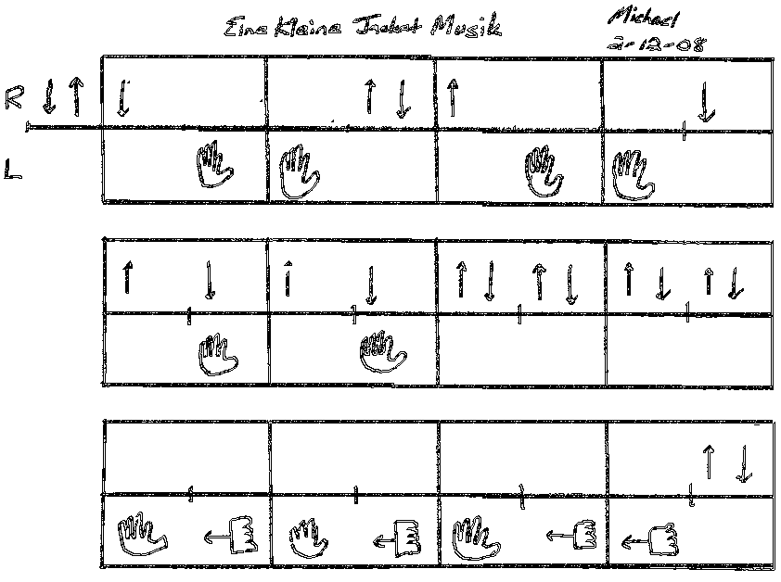

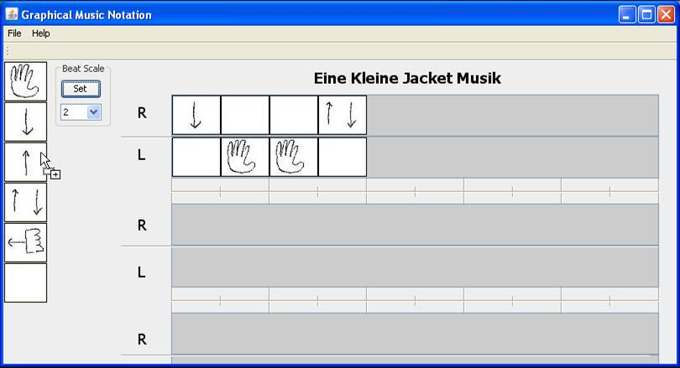

# Table of Contents

*August 3, 2012*

Preface 0-3

*Chapter 1:* Computational Thinking in Music Courses:

How To Get Artsy Types to Start Thinking Like Geeks and Vice Versa 1-1

*Chapter 2:* Imagination and Creativity:

The School-Based Paradox 2-1

*Chapter 3:* Interdisciplinary Teaching:

Two Heads Might Actually Be Better Than One 3-1

*Chapter 3:* Notation and Representation:

Getting Them To Crack the Code 3-1

*Chapter 4:* Getting Them Started:

I Didn’t Know You Could Do That With a Computer 4-1

*Chapter 6:* Platforms and Tools:

Anything You Can Do, I Need To Do Cheaper 6-1

*Chapter 7:* Logistics:

Bit by Bit, Putting It Together 7-1

*Chapter 8:* Assessment:

8-1

*Chapter 9:* Uses of Social Networking Sites:

*Chapter 10:* Performamatics:

# 

# Preface

## This book is about helping students to learn about technology through their interactions with music.

The link between music and technology is inextricable. Digital technology has and continues to alter the way we produce and listen to music. It is now omnipresent in our culture. As its use continues to increase, the likelihood that musicians and technologists will find themselves involved in collaborative projects or work environments also increases.

While digital audio is a relatively new technology, the symbiotic relationship between music and technology actually dates back centuries. Consider, for example, the influence of technology and scientific thinking on the development of the modern piano. What began as a *harpsichord* with plucked strings and a narrow dynamic range evolved into the *fortepiano*, the precursor to what we have come to know as the *piano*, an instrument capable of producing an extreme dynamic range from *pianissimo to fortissimo,* able to hold its own with a symphony orchestra. According to Selfridge-Field [5], the development of the fortepiano was initially viewed as more of a scientific invention. During the 1500s in Florence and much of Europe, it was not unusual for scientists to theorize about musical doctrine. New technologies, materials, and ideas regarding mechanical principles spurred instrument makers to try new approaches to their craft.

The proliferation of interactive digital devices necessitates a workforce skilled in navigating multidisciplinary environments where computer science and the visual, performance, and literary arts converge to create new challenges and opportunities. Thus began our journey into the creation of a general education course focused on the intersection of art and technology, exploring how music and sound are integrated into computer applications.

Our goal seemed simple enough: we wanted students to explore the art and science of digital audio. We planned to have them look at basic end-user applications that promote creative expression and thereby “hook” them into examining the underlying code that allows those programs to function.

Once we began to examine what this meant from a novice perspective, however, and to think about the software we would work with and the projects we would assign, things quickly got complex. We began to re-evaluate and question our own assumptions about the purpose of general education courses and the challenges posed by teaching students outside our respective disciplines. We also came face to face with the challenges of creating a course that was truly interdisciplinary.

From the perspective of a music educator, a hands-on, interdisciplinary project approach allows music education students to gain real-world experience in understanding the benefits and pitfalls of implementing — and possibly designing — technology applications for students growing up under the influence of media. From the perspective of a science educator, the interdisciplinary approach allows computer science students to gain first-hand experience in the myriad of creative decisions that can go into developing a real-world program and the emotional impact that music can have on the end user of any application. In both cases, interdisciplinary work forces students to “think outside the box” to which they have grown accustomed, pushing them to see their work through eyes very different from their own.

As our workforce moves to a more collaborative structure, it is important that students learn to work in teams with students who may not share their skill sets and levels of expertise. They must learn to problem-solve the complex maze of issues that arise when using technology. Providing students with real-world learning contexts fosters an understanding of the interdependencies between sound, image, and technology. Interdisciplinary classes can break down the artificial boundaries of compartmentalized instruction that sometimes get in the way of meaningful and holistic learning. While much of schooling at the secondary and post-secondary level consists of very specific discipline-based content, most of the issues we deal with and problems we are asked to solve in our lives outside the classroom require the kind of thinking that transcends these artificial boundaries.

## This book is for teachers who want to help students see the connection between technology and music.

This book is a resource for teachers and teachers in training who are interested in using technology and the digital arts as a means for the construction of knowledge. It starts at a place of almost universal interest for students: their involvement with music and technology. Technology instruction has traditionally focused on teaching *how* computers and software work and the terminology needed to discuss technology issues. What’s been lacking is *context*: a clear understanding of how technology can be applied throughout one’s educational, personal, and professional experiences. Many of us in the arts have taken or will take a course in “technology” in which the subject is technology itself, devoid of context. In such courses, Woolley notes, the focus is typically on merely learning the “how-to” mechanics of running a given piece of software [7]. Yet as far back as 1995, SRI International argued that technology instruction should be structured around challenging tasks that prepare students for a technology-laden world [6].

We encourage anyone contemplating educational software development to consider these points as well. An understanding of what engages students will give developers insight into how to develop interactive applications from multiple vantage points. If we keep students’ interests in mind, we open the door for them to explore further on their own. Educators and educational software designers need to craft those moments where what we think students *should* do and learn intersects with what they actually *want* to do and learn.

## Today’s complex problems require interdisciplinary solutions.

We often tell our students that once they graduate, they will never again work on a project all by themselves. They will always be working with others. In addition, their co-workers will often be people with backgrounds and points of view very different from their own.

The problems we face in our professional and personal lives are complex. Such problems often benefit from new ways of thinking, and one way to open students’ minds to those new thoughts is to have them work on interdisciplinary teams. Another technique is to put them in situations where they are once again novices. Such situations increase their sensitivity to what it’s like to approach a problem from the viewpoint of a “beginner.”

Using a learner-centered approach that emphasizes project-based experiences, our goal is to provide you with multiple strategies to explore, create, and solve problems with music and technology. The projects we present encourage divergent thinking and promote divergent outcomes while supporting peer-to-peer collaboration, thereby tapping into your students’ social nature. Broad concepts are explored for each type of software application, and we attempt to present the perspective of the software developer as well as the end-user.

Our objective is to help you devise strategies that have educational value as well as relevance for students in terms of “real world” applicability. We want to create learning environments that unleash students’ imaginations while encouraging them to take risks. We want students to be adventurous in their thinking and creative in their problem-solving.

In his book *The Children’s Machine* [4], Seymour Papert challenged traditional schools of thought in which only certain types of knowledge are valuable. Through our own interdisciplinary work [1, 2, 3], we have learned, much as Papert suggested, the importance of students working on ideas and projects that are personally meaningful. As noted earlier, most technology instruction focuses on merely how to use technology without connecting the curriculum to the students’ interests.

This book provides a resource for you and your students to help them make connections between the practical applications of computers and the basic fundamentals of music. We address digital audio issues, end-user preferences in multimedia software development, and the multiple perspectives inherent in an interdisciplinary approach. We provide examples of hands-on activities designed to encourage students to explore the basic principles that underlie today’s technology and to expose them to current multimedia development tools.

## Bibliography for the Preface

[1] Heines, J.M., Martin, F., Roehr, K., Jeffers, J., Greher, G.R., & Strukus, W. (2007). *CPATH CB: Performamatics: Connecting Computer Science to the Performing, Fine, and Design Arts*. www.nsf.gov/awardsearch/showAward.do?AwardNumber= 0722161 *accessed* 4/19/2010.

[2] Heines, J.M., Greher, G.R., & Kuhn, S. (2009). *Music Performamatics: Interdisciplinary Interaction*. Proc. of the 40th ACM Tech. Symposium on CS Education, pp. 478-482. Chattanooga, TN: ACM.

[3] Martin, F., Greher, G.R., Heines, J.M., Jeffers, J., Kim, H.-J., Kuhn, S., Roehr, K., Selleck, N., Silka, L., & Yanco, H. (2009). *Joining Computing and the Arts at a Mid-Size University.* Jrnl. of Computing Sciences in Colleges **24**(6):87-94.

[4] Papert, S. (1993). *The Children's Machine: Rethinking School in the Age of the Computer*. New York: Basic Books.

[5] Selfridge-Field, E. (2005). *The Invention of the Forte Piano as Intellectual History.* Early Music **33**(1):81-94.

[6] SRI International (1995). *Technology and Education Reform*. www2.ed.gov/pubs/EdReformStudies/ EdTech *accessed* 3/19/2010.

[7] Woolley, G. (1998). *Connecting Technology and Learning.* Educational Leadership **55**(5):62-65.